# DEM SR: Unleashing the Power of Remote Sensing

陈前坤1

1(西北农林科技大学 信息工程学院, 陕西 杨陵 712100)

**Abstact：**To address the scarcity of high-resolution Digital Elevation Models (DEMs) for check dam monitoring in the Loess Plateau, this study presents a remote-sensing-image-guided DEM super-resolution (SR) framework. Leveraging Depth Anything Model v2 (DAM), we introduce an Object-Based Decoder intended for instance-level elevation bias correction, design a Degradation Consistency Module to model authentic terrain degradation processes, and develop a Geospatial Fusion Network to integrate Copernicus DEM (30 m) with high-resolution Google Earth imagery (1 m). Training on USGS 3DEP 1-m data as regional proxies centered at GeoDAR dam locations, we validate the method in the Wangmaogou watershed. While results demonstrate significantly reduced splicing artifacts compared to raw DAM outputs, critical implementation flaws emerged: (1) absence of normalization led to invalid elevation ranges; (2) the object decoder exhibited semantic segmentation behavior (feature-based similarity) rather than true instance-level elevation adjustment; (3) the degradation module performed smoothing without resolution reduction, failing to enforce consistency; and (4) patch size incompatibility with DINOv2 (1024 vs. 14) caused spatial discontinuities in mosaics. These findings delineate essential architectural constraints for multi-source DEM fusion, providing specific technical directions for correcting deformation-aware super-resolution systems.

**Key words:** Super Resolution, Dem.

# Introduction

As one of the most important digital representations of terrain, digital elevation models (DEMs) store and express spatial elevation information in a regular raster form(Zhang Y et al. 2022). Such models are widely applied in the domain of Digital Terrain Analysis, including topographic attributes, topographic features/objects and topographic information(Xiong et al. 2022). DEMs are produced from a variety of sources, varying in resolution and cost, from highly accurate and detailed but expensive options to those with coarser resolution and lower cost(Zandsalimi et al. 2025). Among these, the better DEM can be produced from LiDAR, which provides extremely high resolution and vertical accuracy, with points capturing the true 3D nature of the land surface above the ground(Guth and Geoffroy 2021; Carrera-Hernández 2021). However, LiDAR data suffers from several limitations that hinder its routine use for DEM applications: it tends to lack global coverage, be restricted to limited areas, and have low update frequency due to the high cost per unit area, or it often comes with very sparse sampling(Hancock et al. 2021). Open-access spaceborne DEMs, developed based on techniques such as [radar interferometry](https://www.sciencedirect.com/topics/earth-and-planetary-sciences/radar-interferometry), optical stereo matching, or photogrammetry, offer alternative options(Vanmaercke et al. 2021).

In the last two decades, a variety of global or nearly Global digital elevation models (GDEM) have been made freely accessible, including the Shuttle Radar Topography Mission (SRTM) DEM (Farr et al. 2007), the Advanced Spaceborne Thermal Emission and Reflection Radiometer (ASTER) DEM(Hirt et al. 2010), the ALOS World 3D-30 m (AW3D30) DEM(Tadono et al. 2016), the Copernicus DEM(Fahrland), and NASADEM(Crippen et al. 2016). They are composed of grid units, where each grid cell of a specific spatial area may encompass multiple objects with different attributes, resulting in each basic unit typically exhibiting few specific semantics(Xiong et al. 2022). This limitation thereby causes the absence of critical topographic features in these DEM datasets, such as small and medium-sized check dams that remain largely unidentifiable. Recently, the DEM super-resolution (SR) method has emerged as a practical, eﬃcient, and cost-eﬀective solution. Independent of surveying equipment, the DEM SR method reconstructs HR terrain data from existing LR DEMs through data processing techniques(Wang H et al. 2024).

DEM SR aims to improve low-resolution DEMs by estimating unknown elevation values based on known locations(Habib 2021). The process of DEM SR can be understood as a sequence of degradation operations involving blurring, down-sampling, and noise. Specifically, DEM SR acquisition can be modeled as follows:

$I_{LR}=D\left(B\left(I_{HR}\right)\right)+N$ Equation

Where is the blurring operator, which represents the blurring factor introduced by the optical system, such as low-pass filtering, $D$ represents the downsampling operator of the corresponding sensor resolution. And $N$ represents the noise disturbance in the DEM process. $I_{HR}$ and $I_{LR}$ are the corresponding HR DEM and LR DEM of the same target scene, respectively. It can be seen from $I_{LR}$ = $D\left(B\left(I_{HR}\right)\right)+N$ Equation 1 that the DEM SR task is a process of inversely solving DEM-degraded imaging, which is an ill-posed problem because different HR DM may obtain the same LR DEM after passing through a specific DEM model(Xiong et al. 2022).

Reference-based image super-resolution methods (RefSR) have inspired our approach to enhancing DEM resolution while preserving critical terrain features(Su et al. 2025). Google Earth Imagery provides high spatial resolution Image with abundant terrain feature information, such as characteristic details of small and medium-sized check dams. This auxiliary information enables the establishment of an unambiguous correspondence between high-resolution (HR) and low-resolution (LR) DEMs, thereby mitigating the inherent ill-posed nature of the super-resolution problem(Gao et al. 2025).

How to fully utilize the information from Google Earth Imagery and accurately transfer it to DEM reconstruction is the key contribution of this paper.

# Related Work

DEM SR methods can be divided into two types: interpolation-based methods, and learning-based methods. Interpolation-based methods include The Inverse Distance Weighted interpolation method (Achilleos 2011; Lu and Wong 2008), Kriging interpolation (Li X et al. 2017), Bilinear interpolation and Bicubic interpolation (Rees 2000). These models, however, failed to provide satisfactory results, prompting researchers to explore alternative methods (Wang Y et al. 2024).

## Basic DEM SR

Deep learning-based image SR models have been introduced for DEM SR due to DEMs having a regular grid organization similar to images. For example, (Chen Z et al. 2016) applied SRCNN(Dong et al. 2016) method to DEM SR. 再加几个模型 Many of these approaches can obtain better results than traditional DEM interpolation and reconstruction methods. However, unlike natural image, DEMs involve complex terrain characteristics including terrain derivatives (such as slope, aspect) and terrain structural (such as peaks, rivers) (Li W and Hsu 2020; Zhang Y et al. 2022). Consequently, relying solely on global indicators such as RMSE and PSRN is difficult to restore terrain features. Results tend to over smooth high-level features(Zhang Y et al. 2022). TfaSRS (Zhang Y et al. 2022) was the first to design a DEM SR algorithm that using terrain structural lines (near-stream areas) and terrain derivatives (slopes) to optimize local terrain features. Subsequently, many studies used terrain features as local loss (Chen Z et al. 2024; Huo et al. 2025; Shuai et al. 2026; Chen J et al. 2026). In addition, (Chen Z et al. 2024) designed integrated attention mechanism (IAM) network to capture long-range dependencies on geographic feature, such as the continuity of the river and ridge. (Wang H et al. 2024) employed detrending to distinguish between large-scale terrain trends and small-scale residuals in DEMs, thereby enhancing the neural network’s capacity to learn terrain information. However, LR DEM is lacking significant information, it has become extremely challenging to further advance the state-of-the-art of single DEM SR (Zhang Z et al. 2019).

## Reference-based DEM SR

RefSR offers a promising paradigm for enhancing Digital Elevation Models (DEMs) by leveraging high-resolution (HR) remote sensing imagery to compensate for elevation details lost in low-resolution (LR) inputs (Su et al. 2025). (Argudo et al. 2018) pioneered this direction by employing Fully Convolutional Networks to reconstruct 2m DEMs from ~30m inputs, demonstrating the potential of cross-modal fusion. Subsequent studies further exploited image features but remained resolution-constrained: (Gao et al. 2025) developed terrain-guided texture-edge networks (90m→30m), while (Huang et al. 2025) utilized relative depth maps(Yang, Kang, Huang, Xu, et al. 2024) derived from optical imagery (50m→12.5m). However, these outputs still exceed 10m spatial resolution—insufficient for delineating small-scale topographic features.

Recent advances have achieved finer resolutions through diverse architectures. (Zandsalimi et al. 2025) produced 5m DEMs by fusing multi-source data (Landsat, Sentinel, OSM) via U-Net CNNs for urban flood modeling. Concurrently, (Cai and Wilson 2025) reframed DEM SR as depth completion, employing Guided Image Filtering and Spatial Propagation Networks to generate 3m bare-earth DEMs from 30m Copernicus data. Despite these improvements in pixel size, significant methodological gaps persist: (Zandsalimi et al. 2025) simply concatenated multi-source inputs without deeply mining structural texture cues from imagery; (Cai and Wilson 2025) focused primarily on correcting surface features (vegetation/buildings) but neglected to reconstruct micro-topography that is invisible in LR DEMs yet clearly manifested in HR aerial imagery.

Current 30m DEM products comprise grid cells encompassing multiple terrain objects with heterogeneous attributes, resulting in weak semantic specificity at the pixel level (Xiong et al. 2022). Conversely, Google Earth Imagery provides abundant sub-meter terrain structure information, including characteristic signatures of small-to-medium check dams that are indiscernible in coarse elevation grids. Existing methodologies fail to adequately reconstruct these micro-scale geographic objects: earlier approaches suffer from insufficient resolution (Gao et al.; Huang et al.), while recent high-resolution methods (5m–3m) exhibit critical flaws—Zandsalimi et al. (2025) relied on multi-source stacking without extracting fine structural cues from images, and Cai and Wilson (2025) focused on error correction rather than recovering features absent in LR DEMs but present in HR imagery. **This study therefore addresses the critical challenge of fully utilizing Google Earth Imagery to guide accurate DEM reconstruction, with particular emphasis on recovering fine-scale structural features (e.g., check dams) unresolvable in conventional 30m elevation data.**

# Method

## Determine the final resolution

Our goal is to obtain high resolution DEMs in the Loess Plateau (Focus on Gullys). However, what’s the best resolution? On the one hand, if the resolution is too low, our study may not be sufficient to provide effective assistance. On the other hand, if the resolution if too high, the error of target data may increase with the increase of DEM SR, which may also be unnecessary in practical applications. Consequently, We conducted a preliminary test of Depth Anything v2's performance, specifically utilizing Google Earth Imagery at resolutions of 0.5m, 1m, 2m, 5m, and 10m (all images have a resolution of 1024 pixels). Relative depth maps were generated, followed by determining the maximum and minimum elevation values from the corresponding Copernicus DEM regions to calculate absolute (metric) depth. The results are shown in Fig. 1, where: (b), (e), and (d) are composed of multi-patch stitching, (e) and (f) represent full-scale images. The experimental results reveal three critical observations regarding the performance of Depth Anything v2 in generating high-resolution DEM. **First, resolution significantly impacts accuracy**, with finer details increasingly aligning with real-world terrain features as resolution improves. Notably, the 10m-resolution outputs exhibit severe degradation. **Second, the model itself exhibits inherent prediction biases,** manifesting as global elevation deviations in single-patch outputs (e.g., (e) and (f)) and discontinuities at patch boundaries in multi-patch compositions ((b), (c), and (d)).

To sum up, we selected 1m-resolution Google Earth imagery.

|  |  |  |
| --- | --- | --- |
|  | 1. 0.5m resolution | 1. 1m resolution |
|  |  |  |
| 1. 2m resolution | 1. 5m resolution | 1. 10m resolution |  |
|  |  |  |  |

Fig. . Based on Google Earth Imagery images, relative depth estimation is performed using Depth Anything v2, and the elevation information from Copernicus DEM data is integrated to derive the DEM data.(a) is Copernicus DEM with 30m resolution. (b), (c), (d), (e), and (f) represent DEM data obtained at resolutions of 0.5m, 1m, 2m, 5m, and 10m, respectively, with each image having a size of 1024 pixels.

## Data acquisition

Our goal is to obtain 1-m resolution DEMs in the Loess Plateau. However, we lack sufficient 1m-resolution DEMs to train the model used for DEM reconstruction. Fortunately, the USGS provides 1-m resolution DEMs in the USA to support this study. To ensure consistency across datasets, all data were reprojected to the World Geodetic System 1984 (WGS 84) horizontal datum (EPSG 4326) with vertical elevations referenced to the EGM2008 geoid (EPSG 3855), resampled to a spatial resolution of approximately 1 m, and tiled into 1024 × 1024 pixel patches.

### USGS 3DEP DEM

In this study, we utilized the U.S. Geological Survey (USGS) standard one-meter Digital Elevation Model (DEM) as the reference topographic data. Produced through the 3D Elevation Program (3DEP), these hydroflattened bare-earth DEMs (representing terrain surfaces free from vegetation and man-made structures) are derived from high-resolution LiDAR source data and gridded at 1-m spatial resolution with a target nonvegetated vertical accuracy of 19.6 cm at the 95% confidence level (RMSE = 10 cm). The data are georeferenced to the Universal Transverse Mercator (UTM) projection based on the North American Datum of 1983 (NAD 83), with elevations provided as orthometric heights referenced to the North American Vertical Datum of 1988 (NAVD 88) (Anon 2015).

### Copernicus DEM

Due to the Copernicus DEM covers the Loess Plateau region of China, we utilize it as the reference topographic data. Copernicus DEM is the most accurate global DEM (Bielski et al. 2024), and is more accurate over flat terrains featured by bare land or sparse vegetation, offering the best representation of terrain with the highest level of detail (Li H et al. 2022). This Digital Surface Model (DSM) — not a bare-earth DTM — is derived from TanDEM-X radar interferometry and gridded at 1-arc-second (~30 m) spatial resolution with an absolute vertical accuracy of <4 m (LE90) and horizontal accuracy of <6 m (CE90) (European Space Agency and Airbus 2022). The data are georeferenced to the World Geodetic System 1984 (WGS 84) horizontal datum (EPSG 4326) with vertical elevations referenced to the EGM2008 geoid (EPSG 3855).

### Google Earth Imagery

Google Earth Imagery is used to generate the relative depth map. These imagery data is high-resolution from Google Earth, which provides free and public high-resolution remote sensing images covering most of the Earth's land surface at a global scale (Yu and Gong 2012). The imagery is referenced to the World Geodetic System 1984 (WGS84) geographic coordinate system (latitude/longitude), providing a standardized spherical framework for global data integration. Spatial resolution varies by region, with the finest commercially available imagery reaching approximately 0.3–0.6 meters in optimal areas, while the dataset employed in this study maintains a consistent 1-meter ground sampling distance (Li W et al. 2020). These high-resolution RGB images capture fine-scale topographic characteristics, including terrain texture, geometric patterns, and structural elements, enabling detailed visualization of geomorphological features. Recent studies demonstrate the suitability of such imagery for identifying fine-scale terrain discontinuities, including linear erosion features and gully morphologies, based on distinct visual signatures observable in high-resolution RGB data (Mawe et al. 2025; Li H et al. 2022).

## Fine-tuned Depth Anything Model

### Select Depth Anything Model

To date, three versions of the Depth Anything model have been released. Depth Anything mode (DAM) V1 (Yang, Kang, Huang, Xu, et al. 2024) pioneered scalable monocular depth estimation by leveraging 62 million unlabeled real images through a challenging student-teacher training paradigm, offering models up to ViT-L (335.3M parameters) with strong zero-shot generalization. Depth Anything V2 (Yang, Kang, Huang, Zhao, et al. 2024) advanced this approach by replacing noisy real-world labels with precise synthetic data and scaling the teacher model capacity to 1.3B parameters, yielding significantly finer geometric details and robustness across diverse scenarios. Depth Anything V3 (Lin et al. 2025) further unified the framework to handle arbitrary numbers of input views via a minimal depth-ray representation, enabling joint depth and camera pose estimation with a single plain transformer architecture. To select the best one, we conducted comparative experiments. The specific model configurations are detailed in Table 1, where we selected the ViT-L variant of V1 (335.3M), the Giant variant of V2 (1.3B), and the Monocular Depth variant of V3 (0.35B) for evaluation.

Table Three versions of Depth Anything model and their params.

|  |  |  |
| --- | --- | --- |
| Model | Weight/Params | Link |
| DAM v1 | Larges/335.3M | https://github.com/LiheYoung/Depth-Anything |
| DAM v2 | Giant/1.3B | https://github.com/DepthAnything/Depth-Anything-V2 |
| DAM v3 | Monocular Depth/0.35B | https://github.com/ByteDance-Seed/depth-anything-3 |

Five scenes were selected to evaluate the performance of the three models. As shown in Fig. 2, the DAM v2 Model achieves the best performance. Specifically, DAM v2 demonstrates superior stability, which in Scene 4 of Fig. 2, DAM v1 and DAM v2 are affected by interference from spliced remote sensing images. By comparison, DAM v2 achieves superior restoration, exhibiting higher similarity to Scene 4(b) of Figure 2. DAM v2 have the finest details, accurately delineating the morphology of river channels, bridges, and buildings, whereas in Scene 3 of Fig. 2, DAM v1’s results distortion and DAM v3’s show certain deviations.

From this experiment, we conclude that:

1. DAM v2 generates superior result that align with visual perception. The model can identify dams and buildings, proving its robust feature extraction ability. However, certain deviations in the relative depth map. For example, in Scene 1 of Fig. 2, the dams under construction has its elevation underestimated.
2. The USGS DEM is bare-earth DEM, its elevation does not match the relative height obtained from remote sensing images and the Copernicus DEM, which is particularly evident in Scene 3 of Fig. 2 and Scene 5 of Fig. 2. This difference warrants attention.

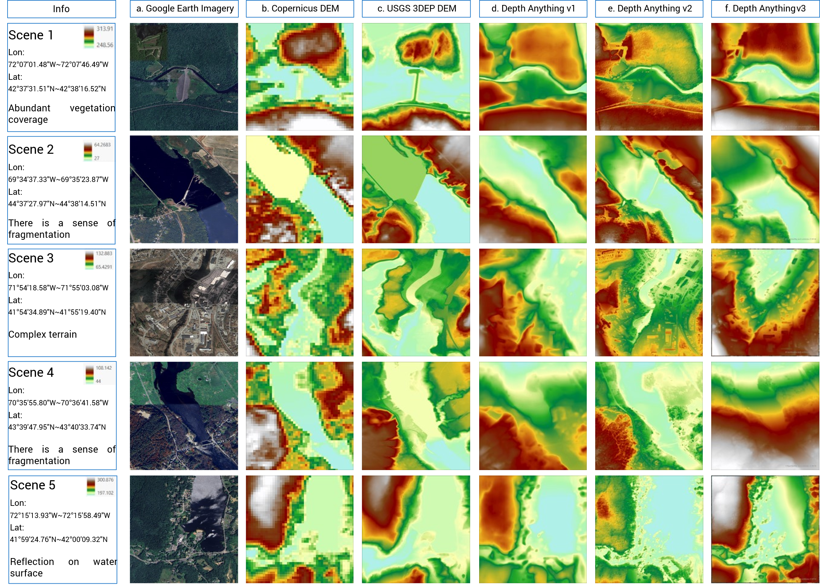

Fig. . The result of three version's DAM Model without any training.

### Training Area Selected and Dataset Construction

Although the Copernicus DEM is a DSM, it does not align with the Google Earth imagery (e.g., Scenes 1, 4, and 5 in Fig. 2), which we infer is due to thick vegetation coverage. Subsequently, we conducted a comparison between the USA and the Loess Plateau. As shown in Fig. 3, the Loess Plateau has relatively sparse vegetation coverage, where the Copernicus DEM aligns with both the Google Earth imagery and the HR DEM.

Consequently, we prioritize selecting regions with sparse vegetation coverage in the USA. (Wang J et al. 2022) constructed the Georeferenced global Dams And Reservoirs (GeoDAR) dataset, which providing the location of dams in USA. As shown in Scene 1 of Fig. 2 and Scene 2 and 3 of Fig. 3, these dams are bare-earth structures, where the elevation aligns with features in the Google Earth imagery, focusing on them and their surrounding areas (approximately 1024m × 1024 m with 1024 pixel × 1024 pixel) allows us to avoid excessive training of the model on vegetation-to-elevation estimation patterns, which would be ineffective for the Loess Plateau. This approach instead enables the model to learn dam-specific features, thereby facilitating the reconstruction of over 50000 check dams in the Loess Plateau (Zeng et al. 2024).

Two points warrant attention:

1. Although the Copernicus and USGS DEMs exhibit similar elevations with consistent overall trends, certain deviations remain that cannot be readily rectified through simple interpolation.
2. These dams are larger than typical check dams (e.g. Scene 4 of Fig. 3). While they cannot be detected in the Copernicus DEM, they are visible in the HR DEM. Nevertheless, they share similar morphological features with check dams.

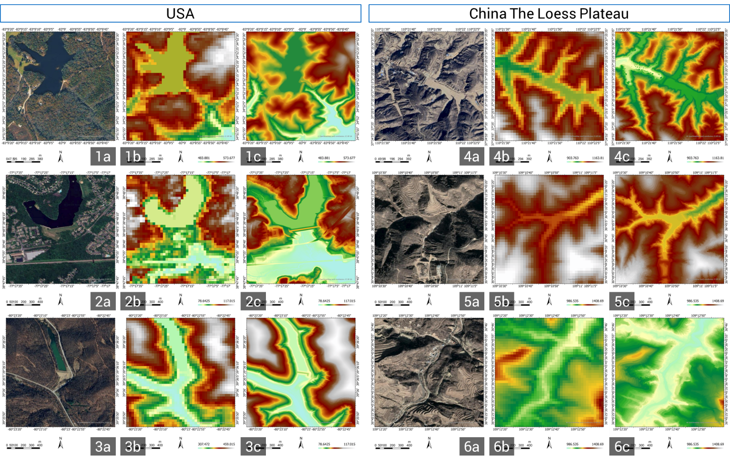

Fig. . Differences between the Loess Plateau regions of the United States and China. The LR DEM is Copernicus DEM. For USA, the HR DEM is USGS 3DEP DEM. For The Loess Plateau, we conducted a field survey to get the HR DEM.

We planed using each dam within the USA as an instance in the GeoDAR data. Due to time constraints, only datasets from 12 states were constructed. GeoDAR v1.1 was used to generation Dataset. Specifically, this dataset holds dam points, we center around these points, and expand outward until 1024, so we obtained the range of each training data. Then we crop and resample based on the data range to obtained the Copernicus DEM, USGS 3DEP, and Google Earth imagery required for training. There are total 1531 samples, and train samples 1224, test samples 307.

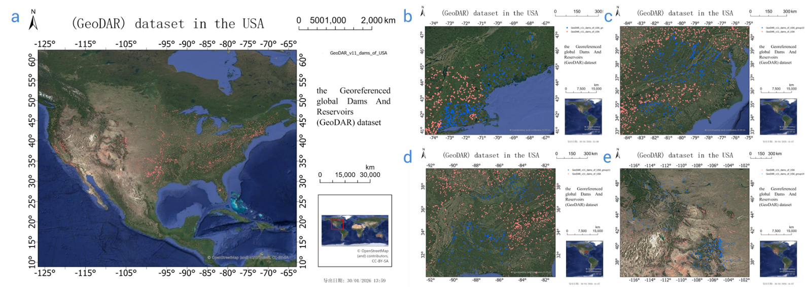

Fig. Training Locations is the USA. Including Maine, Massachusetts, Connecticut, Virginia, West Virginia, South Carolina, Kentucky, Mississippi, Alabama, Idaho, Montana and Colorado.

### Object-Based Decoder

As previously noted, discrepancies exist between USGS DEM elevations and relative heights derived from remote sensing imagery. While DAM v2 producers superior results that align with visual perception (rendering the elevation mismatch acceptable). We observed systematic prediction biases with specific ranges (e.g., consistent underestimation of entire dam structures (Scene 1 of Fig. 2)). To address this limitation, we introduced an Object-Based Decoder that applies an object-level bias correction to the relative depth estimates. This approach not only preserves the model’s fine-detail generation capabilities but also enhances its robustness against inherent data variations, thereby improving performance in remote sensing applications.

Our framework treats DAM v2 as a frozen features extractor, maintaining the pre-trained DINOv2 encoder and DPT decoder weights fixed to preserve their geometric priors. Parallel to the frozen decoder, we append a lightweight Instance Segmentation Head that process multi-scale encoder features to identify cohesive terrain objects. This head predicts pixel-wise instance assignments and a per-instance bias vector, which are aggregated via soft-attention into a dense bias map $B$. Formally, for an input image, the enhanced relative depth is computed as:

$D_{enhanced}=RuLU (D_{relative}+B × γ+ β)$ Equation 2

Where $D_{relative}$ is the frozen decoder output, and $γ$, $β$ are learnable affine parameters. This design ensures that all pixels belonging to the same object (e.g., a dam body) receive uniform elevation offsets, correcting systematic deviations while maintaining internal structural consistency.

## DEM SR

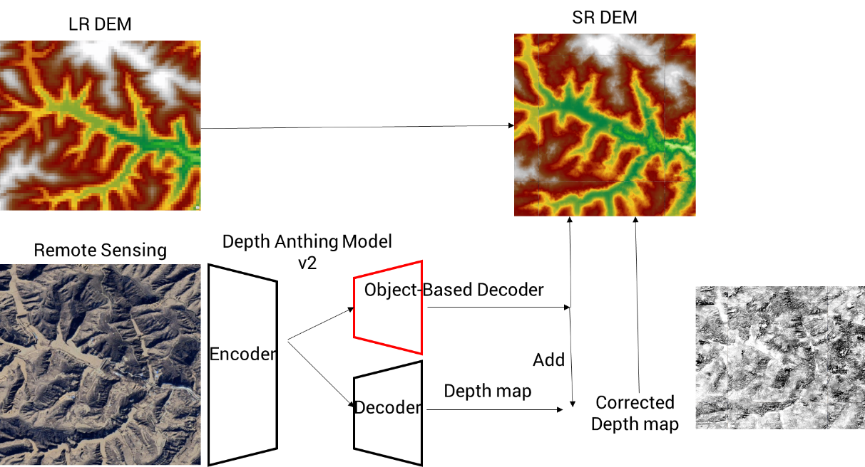

Fig. Architecture

### Degradation Consistency Module

The relationship between HR and LR DEM is inherently non-linear and cannot be adequately modeled by simple interpolation or fixed-kernel downsampling. Unlike natural images where bicubic degradation serves as a reasonable approximation, DEM SR involves complex geomorphological process including terrain smoothing, elevation averaging over grid cells, and sensor-specific artifacts inherent to radar interferometry (e.g., TanDEM-X for Copernicus). To address this, we introduce a Degradation Consistency Module that explicitly learns the mapping from HR DEM to LR DEM, serving two critical purpose in our framework.

1. During training with paired data (where USGS DEM is available), this module learns the authentic degradation process from the predicted HR DEM to the input LR DEM (Copernicus DEM). The learned mapping captures terrain-specific smoothing patterns that differ from standard image downsampling, ensuring that the super-resoloved elevation surfaces are geomorphologically consistent with LR DEM when subjected to the observed degradation process.
2. More importantly, this mechanism enables self-supervised training in unpaired regions. In areas where HR DEM Data is rarely (e.g., the Loess Plateau), the degradation consistency provides a supervisory signal through cyclic validation: if the predicted HR DEM, when passed through the learned degradation network, accurately reconstructs the original LR DEM, the super-resolution result is considered geometrically consistent, can be used for training. This eliminates the dependency on scarce HR DEM while maintaining reconstruction quality.

The degradation network employs an encoder-decoder architecture with residual connections. The encoder progressively downsamples the input HRDEM through strided convolutions to capture multi-scale terrain features, while the decoder reconstructs the LR representation via transposed convolutions. Formally, given a predicted HR DEM , the network generates a mapped LR DEM . The consistency loss is computed as the RMSE between $(D_{LR}^{mapped}$ and the original Copernicus DEM $D_{LR}$:

$L_{map}=RMSE(D_{LR}^{mapped}, D_{LR})$ Equation 3

### Geospatial Fusion and Super-Resolution

While the enhanced depth map from DAM models provides high-fidelity visual details, it remains fundamentally an image-based prediction lacking accurate absolute elevation reference and geospatial consistency. The super-resolution network bridges this gap by fusing three sources: the LR DEM (providing absolute elevation anchor points), the enhanced relative depth map (providing high-frequency terrain details), and the instance bias map (identifying regions requiring elevation adjustment). Through residual blocks equipped with instance-guided attention mechanisms, the network learns to distribute the absolute elevation information from the LR DEM across the high-resolution grid while incorporating the relative depth details. The network effectively adjusts the image-derived depth predictions to align with the geospatial reality encoded in the Copernicus data, outputting a HR DEM where absolute elevations are preserved yet fine-scale features from the imagery are accurately reconstructed.

# Conclusion

Okay, when I first saw these results, it was already January 31st, 2025—it was too late. The outcomes diverged significantly from my expectations. On a positive note, however, the results did not exhibit any bizarre anomalies (as illustrated in Fig. 5(d)), and the splicing artifacts have been substantially reduced. Yet, several critical issues have become apparent:

**First, regarding the Fine-tuned Depth Anything Model.** As illustrated in Fig. 5(f), I failed to implement a proper normalization operation, which resulted in an incorrect value range for the outputs. This is a fundamental error that requires immediate correction.

**Second, and more critically, the Fine-tuned Depth Anything Model.** While the model appears capable of recognizing objects—the feature maps resemble sketches outlining the terrain contours—the predicted elevations are fundamentally wrong! Areas with similar visual features are assigned nearly identical elevation values, completely disregarding the actual topographic undulations. This is essentially behaving like semantic segmentation, whereas what I actually need is *instance segmentation*: an adaptive mechanism that adjusts the overall elevation of a specific local region (like applying a Photoshop mask to a particular object). I must revisit the code architecture for this component and redesign the associated loss functions to enforce instance-level elevation consistency rather than feature-based similarity.

**Third, the Degradation Consistency Module.** Since I pre-inserted the LR DEM into the HR DEM via nearest-neighbor interpolation, the output—despite its higher resolution—still visually resembles the LR DEM. However, I completely overlooked that passing the HR DEM through the Degradation Consistency Module doesn't actually downsample it back to the LR DEM resolution; instead, it merely performs a smoothing operation. Oh my god—this means the module isn't enforcing true resolution consistency at all. **The obvious fix is to append a proper downsampling layer at the end, or progressively reduce the spatial dimensions through strided convolutions to genuinely match the LR resolution.**

**Fourth, the tiling issue.** My patch size is 1024 pixels, which is not a multiple of 14 (the DINOv2 patch size). Consequently, during processing, the outermost pixels are cropped, reducing the effective output to 1022 pixels. This creates gaps between adjacent tiles in the stitched result, as they are no longer spatially contiguous.

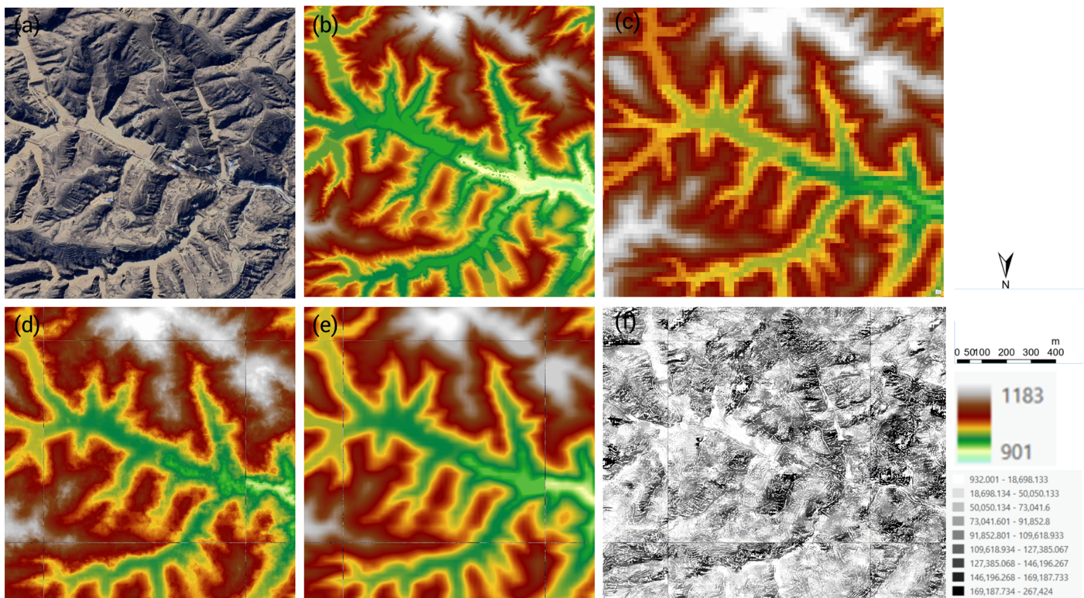

Fig. . The predicted result in the WangMaoGou (in the Loess Plateau). (a): The Google Earth imagery. (b) The HR DEM obtained from field research. (c) The Copernicus DEM. (d) The HR DEM obtained from Model. (e) The LR DEM from (d) used Degradation Consistency Module. (f) The feature from Fine-tuned DAM Model.

# Data Availability

The datasets used in this study, including USGS 3DEP DEM, Copernicus DEM, Google Earth imagery and GeoDAR v1.1 are freely online:

USGS 3DEP DEM: https://gis1.oit.ohio.gov/geodatadownload/

Copernicus DEM: [browser.dataspace.copernicus.eu](https://browser.dataspace.copernicus.eu/)

Google Earth imagery: <https://code.earthengine.google.com/>

GeoDAR: <https://doi.org/10.5281/zenodo.6163413>

The code is available: [isKunner/TheSotrageCapacityOfCheckDam](https://github.com/isKunner/TheSotrageCapacityOfCheckDam)

# References

1. Anon, 2015. Techniques and Methods[R].
2. Achilleos G A, 2011. The Inverse Distance Weighted interpolation method and error propagation mechanism – creating a DEM from an analogue topographical map[J]. Journal of Spatial Science, 56(2): 283-304.
3. Bielski C, López-Vázquez C, Grohmann C H, Guth P L, Hawker L, Gesch D, Trevisani S, Herrera-Cruz V, Riazanoff S, Corseaux A, Reuter H I, Strobl P, 2024. Novel Approach for Ranking DEMs: Copernicus DEM Improves One Arc Second Open Global Topography[J]. IEEE Transactions on Geoscience and Remote Sensing, 62: 1-22.
4. Cai X, Wilson M D, 2025. JSPSR: Joint Spatial Propagation Super-Resolution Networks for Enhancement of Bare-Earth Digital Elevation Models from Global Data[J]. Remote Sensing, 17(21): 3591.
5. Carrera-Hernández J J, 2021. Not all DEMs are equal: An evaluation of six globally available 30 m resolution DEMs with geodetic benchmarks and LiDAR in Mexico[J]. Remote Sensing of Environment, 261: 112474.
6. Chen J, Wu Z, Yang F, Wang M, Bu X, Cui X, Shang J, Zhao D, Zhou J, Liu Y, 2026. RRDPM: Relay residual diffusion probabilistic model for global typical land and seabed DEM super-resolution[J]. International Journal of Applied Earth Observation and Geoinformation, 146: 105031.
7. Chen Z, Han X, Ma X, 2024. Combining Contextual Information by Integrated Attention Mechanism in Convolutional Neural Networks for Digital Elevation Model Super-Resolution[J]. IEEE Transactions on Geoscience and Remote Sensing, 62: 1-16.
8. Chen Z, Wang X, Xu Z, Hou W, 2016. CONVOLUTIONAL NEURAL NETWORK BASED DEM SUPER RESOLUTION[J]. ISPRS - International Archives of the Photogrammetry, Remote Sensing and Spatial Information Sciences, XLI-B3: 247-250.
9. Crippen R, Buckley S, Agram P, Belz E, Gurrola E, Hensley S, Kobrick M, Lavalle M, Martin J, Neumann M, Nguyen Q, Rosen P, Shimada J, Simard M, Tung W, 2016. NASADEM GLOBAL ELEVATION MODEL: METHODS AND PROGRESS[J]. ISPRS - International Archives of the Photogrammetry, Remote Sensing and Spatial Information Sciences, XLI-B4: 125-128.
10. Dong C, Loy C C, He K, Tang X, 2016. Image Super-Resolution Using Deep Convolutional Networks[J]. IEEE Transactions on Pattern Analysis and Machine Intelligence, 38(2): 295-307.
11. European Space Agency, Airbus, 2022. Copernicus DEM[DS]. (2022)[2026-01-29].
12. Fahrland E. DOCUMENT PREPARATION[J]. 2022.
13. Farr T G, Rosen P A, Caro E, Crippen R, Duren R, Hensley S, Kobrick M, Paller M, Rodriguez E, Roth L, Seal D, Shaffer S, Shimada J, Umland J, Werner M, Oskin M, Burbank D, Alsdorf D, 2007. The Shuttle Radar Topography Mission[J]. Reviews of Geophysics, 45(2): 2005RG000183.
14. Gao B, Yue L, Qiu Z, Yuan Q, Shen H, 2025. Exploring the integration of auxiliary modal information from remote sensing images for DEM super-resolution[J]. International Journal of Geographical Information Science, 39(12): 2886-2912.
15. Guth P L, Geoffroy T M, 2021. LiDAR point cloud and *ICESat‐2* evaluation of 1 second global digital elevation models: Copernicus wins[J]. Transactions in GIS, 25(5): 2245-2261.
16. Habib M, 2021. Evaluation of DEM interpolation techniques for characterizing terrain roughness[J]. CATENA, 198: 105072.
17. Hancock S, McGrath C, Lowe C, Davenport I, Woodhouse I, 2021. Requirements for a global lidar system: spaceborne lidar with wall-to-wall coverage[J]. Royal Society Open Science, 8(12): 211166.
18. Hirt C, Filmer M S, Featherstone W E, 2010. Comparison and validation of the recent freely available ASTER-GDEM ver1, SRTM ver4.1 and GEODATA DEM-9S ver3 digital elevation models over Australia[J]. Australian Journal of Earth Sciences, 57(3): 337-347.
19. Huang W, Sun Q, Guo W, Xu Q, Wen B, Gao T, Yu A, 2025. Multi-Modal Dem Super-Resolution Using Relative Depth: A New Benchmark and Beyond[A]. SSRN.
20. Huo Z, Xi M, He J, Li Z, Wen J, 2025. Random Undersampled Digital Elevation Model Super-Resolution Based on Terrain Feature-Aware Deep Learning Network[J]. IEEE Journal of Selected Topics in Applied Earth Observations and Remote Sensing, 18: 9593-9604.
21. Li H, Zhao J, Yan B, Yue L, Wang L, 2022. Global DEMs vary from one to another: an evaluation of newly released Copernicus, NASA and AW3D30 DEM on selected terrains of China using ICESat-2 altimetry data[J]. International Journal of Digital Earth, 15(1): 1149-1168.
22. Li W, Dong R, Fu H, Wang J, Yu L, Gong P, 2020. Integrating Google Earth imagery with Landsat data to improve 30-m resolution land cover mapping[J]. Remote Sensing of Environment, 237: 111563.
23. Li W, Hsu C Y, 2020. Automated terrain feature identification from remote sensing imagery: a deep learning approach[J]. International Journal of Geographical Information Science, 34(4): 637-660.
24. Li X, Shen H, Feng R, Li J, Zhang L, 2017. DEM generation from contours and a low-resolution DEM[J]. ISPRS Journal of Photogrammetry and Remote Sensing, 134: 135-147.
25. Lin H, Chen S, Liew J, Chen D Y, Li Z, Shi G, Feng J, Kang B, 2025. Depth Anything 3: Recovering the Visual Space from Any Views[A]. arXiv.
26. Lu G Y, Wong D W, 2008. An adaptive inverse-distance weighting spatial interpolation technique[J]. Computers & Geosciences, 34(9): 1044-1055.
27. Mawe G I, Landu E L, Dujardin E, Imwangana F M, Bielders C, Hubert A, Michellier C, Nzolang C, Poesen J, Dewitte O, Vanmaercke M, 2025. Mapping urban gullies in the Democratic Republic of the Congo[J]. Nature, 644(8078): 952-959.
28. Rees W G, 2000. The accuracy of Digital Elevation Models interpolated to higher resolutions[J]. International Journal of Remote Sensing, 21(1): 7-20.
29. Shuai D, Deng Q, Zhong W, Lu Y, Zhong Q, Wang Z, 2026. Bridging land and sea: A latent diffusion framework for high-resolution ocean floor mapping[J]. Expert Systems with Applications, 297: 129386.
30. Su H, Li Y, Xu Y, Fu X, Liu S, 2025. A review of deep-learning-based super-resolution: From methods to applications[J]. Pattern Recognition, 157: 110935.
31. Tadono T, Nagai H, Ishida H, Oda F, Naito S, Minakawa K, Iwamoto H, 2016. GENERATION OF THE 30 M-MESH GLOBAL DIGITAL SURFACE MODEL BY ALOS PRISM[J]. ISPRS - International Archives of the Photogrammetry, Remote Sensing and Spatial Information Sciences, XLI-B4: 157-162.
32. Vanmaercke M, Panagos P, Vanwalleghem T, Hayas A, Foerster S, Borrelli P, Rossi M, Torri D, Casali J, Borselli L, Vigiak O, Maerker M, Haregeweyn N, De Geeter S, Zgłobicki W, Bielders C, Cerdà A, Conoscenti C, De Figueiredo T, Evans B, Golosov V, Ionita I, Karydas C, Kertész A, Krása J, Le Bouteiller C, Radoane M, Ristić R, Rousseva S, Stankoviansky M, Stolte J, Stolz C, Bartley R, Wilkinson S, Jarihani B, Poesen J, 2021. Measuring, modelling and managing gully erosion at large scales: A state of the art[J]. Earth-Science Reviews, 218: 103637.
33. Wang H, Xiong L, Hu G, Cao H, Li S, Tang G, Zhou L, 2024. DEM super-resolution framework based on deep learning: decomposing terrain trends and residuals[J]. International Journal of Digital Earth, 17(1): 2356121.
34. Wang J, Walter B A, Yao F, Song C, Ding M, Maroof A S, Zhu J, Fan C, McAlister J M, Sikder S, Sheng Y, Allen G H, Crétaux J F, Wada Y, 2022. GeoDAR: georeferenced global dams and reservoirs dataset for bridging attributes and geolocations[J]. Earth System Science Data, 14(4): 1869-1899.
35. Wang Y, Jin S, Yang Z, Guan H, Ren Y, Cheng K, Zhao X, Liu X, Chen M, Liu Y, Guo Q, 2024. TTSR: A Transformer-Based Topography Neural Network for Digital Elevation Model Super-Resolution[J]. IEEE Transactions on Geoscience and Remote Sensing, 62: 1-19.
36. Xiong L, Li S, Tang G, Strobl J, 2022. Geomorphometry and terrain analysis: data, methods, platforms and applications[J]. Earth-Science Reviews, 233: 104191.
37. Yang L, Kang B, Huang Z, Xu X, Feng J, Zhao H, 2024. Depth Anything: Unleashing the Power of Large-Scale Unlabeled Data[A]. arXiv.
38. Yang L, Kang B, Huang Z, Zhao Z, Xu X, Feng J, Zhao H, 2024. Depth Anything V2[A]. arXiv.
39. Yu L, Gong P, 2012. Google Earth as a virtual globe tool for Earth science applications at the global scale: progress and perspectives[J]. International Journal of Remote Sensing, 33(12): 3966-3986.
40. Zandsalimi Z, Barbosa S A, Alemazkoor N, Goodall J L, Shafiee-Jood M, 2025. Deep learning-based downscaling of global digital elevation models for enhanced urban flood modeling[J]. Journal of Hydrology, 653: 132687.
41. Zeng Y, Jing T, Xu B, Yang X, Jian J, Zong R, Wang B, Dai W, Deng L, Fang N, Shi Z, 2024. Vectorized dataset of silted land formed by check dams on the Chinese Loess Plateau[J]. Scientific Data, 11(1): 348.
42. Zhang Y, Yu W, Zhu D, 2022. Terrain feature-aware deep learning network for digital elevation model superresolution[J]. ISPRS Journal of Photogrammetry and Remote Sensing, 189: 143-162.
43. Zhang Z, Wang Z, Lin Z, Qi H, 2019. Image Super-Resolution by Neural Texture Transfer[C]//2019 IEEE/CVF Conference on Computer Vision and Pattern Recognition (CVPR). Long Beach, CA, USA: IEEE: 7974-7983.

# Appendix

## Illustration

为避免上文的用词不当，此处用中文介绍一下背景。本人研究是估算黄土高原淤地坝的剩余库容。黄土高原沟壑纵横，水土流失严重，因此人们在沟壑中修建了淤地坝来拦泥保土，但是很多淤地坝运行多年，还能存储多少泥沙不清楚，需要计算。这需要用到DEM数据，但是30m分辨率的数据不足以支撑计算，一方面是因为中小型淤地坝的坝高在30m数据中可能显现不出来，另一方面是在30m数据的基础上，即使知道高程，计算的库容也会有1倍的偏差。

导师建议我使用超分的方法来构造更好的DEM数据。然而，淤地坝是人造建筑物，如果在DEM数据中本身就没有显现，超分怎么能超分出来呢？在相关工作中，我偶然发现了利用Depth Anything Model辅助进行超分的，这给了我灵感，但是那篇论文，甚至我目前读到的所有论文，并没有关注这些淤地坝这种结构的超分的效果，因此这是我想进行此研究的初衷。

随后，在计算机视觉和深度学习课程的论文汇报中分别研读了Depth Anything v1 和 Depth Anything v2，认为是可行的。由于其是Transformer架构，因此将对其的改进作为本次课程作业。

随后数据的构造过程花费了大量的力气。为下载数据，找相应的API接口，是在找不到，找到对应存储原文件的位置，进行手动的文件查找，使整个进度严重滞后。导致在31日也仅进行了一个简单的模型训练尝试。同时也是希望锻炼英语能力，以及能够及时的将看到的英文文献以英文呈现出来（担心过后中文转英文出现偏颇），所以内容使用的英文。

## WMG

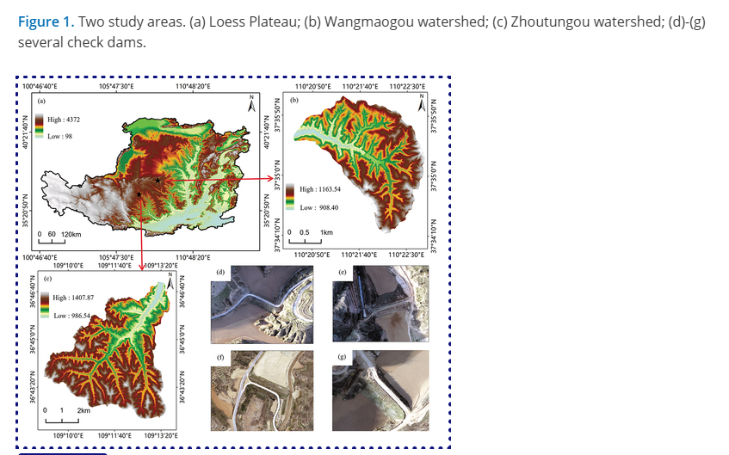

## Data Load

The program traverses each region and calculates the file name of the corresponding Copernicus DEM to download the corresponding file (Fig. 7). However, some points are ignored during the traversal process, and the print() function is added. It's amazing, but the specific reason is unknown.

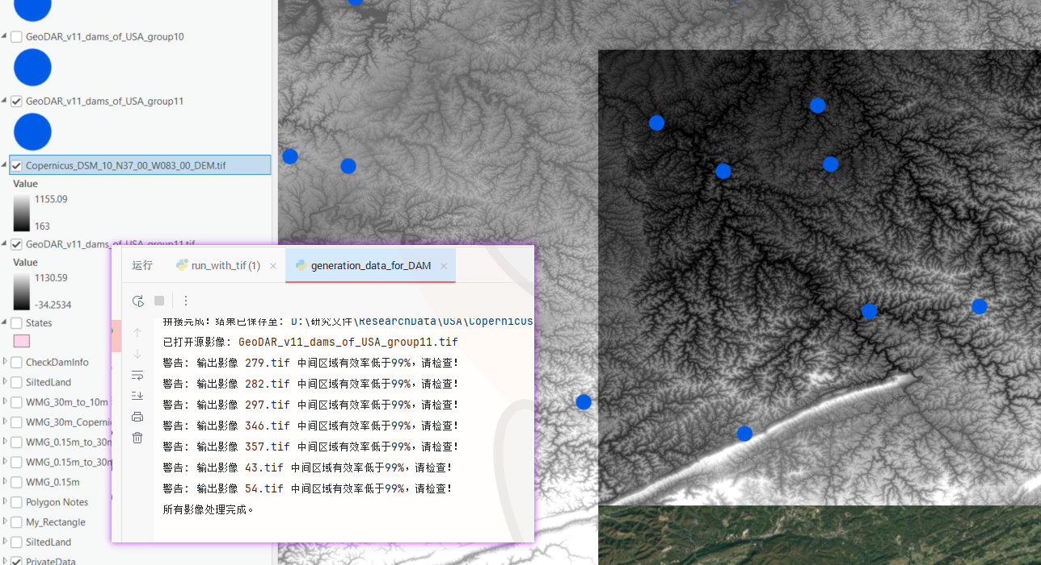

Fig. . The illustrated area was skipped during program execution and was not downloaded manually

官网文件缺失：

[rockyweb.usgs.gov/vdelivery/Datasets/Staged/Elevation/1m/Projects/ME_MidCoast_2021_B21/0_file_download_links.txt](https://rockyweb.usgs.gov/vdelivery/Datasets/Staged/Elevation/1m/Projects/ME_MidCoast_2021_B21/0_file_download_links.txt) 中的TxT文件缺少：

<https://prd-tnm.s3.amazonaws.com/StagedProducts/Elevation/1m/Projects/ME_MidCoast_2021_B21/TIFF/USGS_1M_19_x52y498_ME_MidCoast_2021_B21.tif>